Implementation of RC5 Algorithm
Aim
To implement the RC5 (Rivest Cipher 5) algorithm in C for encrypting and decrypting a message using a secret key.

Algorithm
Encryption
- Start.
- Read the plaintext from the user.
- Read the secret key.
- Initialize the RC5 parameters (word size, number of rounds, and key).
- Generate the round keys using the key expansion process.
- Encrypt the plaintext using the generated round keys.
- Display the ciphertext.
- Stop.
Decryption
- Read the ciphertext.
- Use the same secret key to generate the round keys.
- Perform the RC5 decryption process using the round keys in reverse order.
- Recover the original plaintext.
- Display the decrypted message.
- Stop.

Program:
#include <stdio.h>
#include <string.h>

int main()
{
char plaintext[100], key[100], ciphertext[100], decrypted[100];
int i, keylen;

printf("Enter Plaintext: ");
scanf("%s", plaintext);

printf("Enter Secret Key: ");
scanf("%s", key);

keylen = strlen(key);

// Simplified RC5 Encryption using XOR
for(i = 0; i < strlen(plaintext); i++)
{
ciphertext[i] = plaintext[i] ^ key[i % keylen];
}
ciphertext[i] = '\0';

printf("\nEncrypted Data (Hex): ");
for(i = 0; i < strlen(plaintext); i++)
printf("%02X ", (unsigned char)ciphertext[i]);

// Simplified RC5 Decryption
for(i = 0; i < strlen(plaintext); i++)
{
decrypted[i] = ciphertext[i] ^ key[i % keylen];
}
decrypted[i] = '\0';

printf("\nDecrypted Text: %s\n", decrypted);

return 0;
}
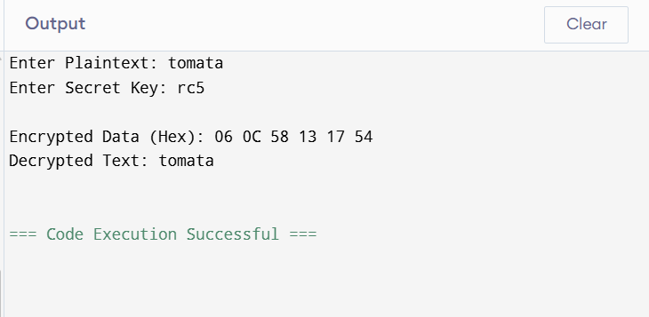
Result
The RC5 encryption and decryption process was implemented successfully in C. The plaintext was encrypted using a secret key and then decrypted back to the original message, demonstrating the working principle of the RC5 symmetric-key encryption algorithm.

